Rodeo Roll-Out
Welcome back COLTS! Join the car rodeo and pick up important items for your student(s) learning this school year! The Rodeo Roll-Out will be August 31. This will take the place of the Colt Corral and Meet and Greet (which are cancelled). The rodeo is a drive through event, so you don’t even have to get out of your car!

Students will be receiving:

- Computer
- Textbooks
- Workbooks
- Basic School supplies
- And More!
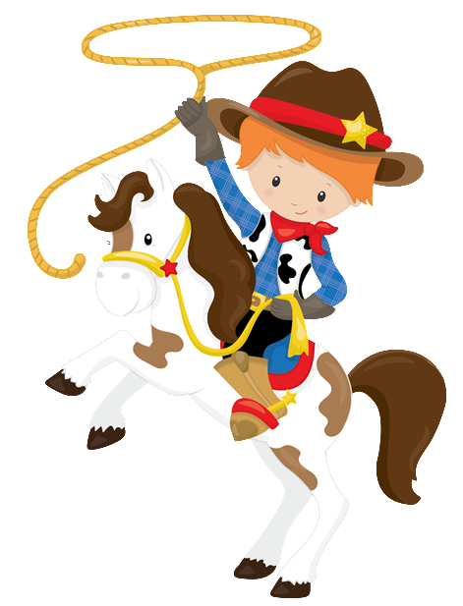

To help us get your materials to you faster while maintaining a good flow of traffic, please put your student’s name in LARGE CLEAR letters displayed on your passenger side window. To pace the traffic coming in and out of the parking lot, your assigned time will be by last name.
If possible, please come at your assigned time to get your student(s):
A-C Families from 9-10
D-J Families from 10-11
K-O Families from 11-12
P-S Families from 1-2
T-Z Families from 2-3

If you are unable to make your assigned time, please join us between 9-12 and 1-3pm on August 31st.

See ya at the rodeo, partner!

